**Neusoft Ruidao internal disclosure**

Document number: D00 0 -2019001

Neusoft Cloud HIS Hospital Management System

Requirements Specification

Version : 1.0.0-0.0.0​​​​

Neusoft Ruidao Education Information Technology Co., Ltd.

**(All rights reserved. Reproduction prohibited.)**

**Copyright © Neusoft Educational Information Technology Co., Ltd**

**All Rights Reserved**

File modification control

|  |  |  |  |
| --- | --- | --- | --- |
| **Modification number** | **Version** | **Modification of terms and content** | **Modified Date** |
| 1 | 1.0.0-0.0.0​​​ | create | 20 22 - 4 - 5 |
|  |  |  |  |
|  |  |  |  |
|  |  |  |  |
|  |  |  |  |
|  |  |  |  |
|  |  |  |  |
|  |  |  |  |
|  |  |  |  |
|  |  |  |  |
|  |  |  |  |
|  |  |  |  |
|  |  |  |  |
|  |  |  |  |
|  |  |  |  |

**Table of contents**

1. Neusoft Cloud HIS System Overview 1

1.1 Introduction to HIS system 1

1.2 Neusoft Cloud HIS Value Proposition and Vision 1

1.3 Neusoft Cloud HIS Hospital Management System Functional Architecture 2

2. Business process diagram 3

3. Basic information maintenance 4

3.1 User Management 4

3.2 Department Management 4

3.3 Registration level management 4

3.4 Settlement Category Management 5

3.5 Diagnostic Catalog Management 5

3.6 Management of non-drug charges 5

3.7 Doctor Scheduling Management 5

4. Outpatient registration fee 6

4.1 On-site registration 6

4.2 Charges 7

4.3 Withdrawal 8

4.4 Refund 8

4.5 Patient expense inquiry 8

4.6 Daily payment for toll collectors 8

5. Outpatient doctor workstation 9

5.1 Outpatient medical record home page 10

5.2 Inspection Application 13

5.3 Inspection Application 14

5.4 Outpatient diagnosis 14

5.5 Disposal Application 15

5.6 Prescription of patent medicine 15

5.7 Herbal prescriptions 18

5.8 End of consultation 19

5.9 Patient expense details inquiry 19

5.10 Medical record template management 19

5.11 Inspection set management 20

5.12 Inspection set management 20

5.13 Disposal set management 21

5.14 Prescription set management 21

5.15 Personal Workload Statistics 21

6. Outpatient medical technology workstation 21

6.1 Inspection and registration 21

6.2 Inspection\Test result entry 22

6.3 Personal Workload Statistics 22

7. Outpatient pharmacy workstation 22

7.1 Outpatient medication 22

7.2 Outpatient medication withdrawal 24

7.3 Drug Catalog Management 25

8. Outpatient financial management 26

8.1 Expense Account Management 26

8.2 Outpatient day tuberculosis 26

8.3 Statistics on workload of outpatient departments 26

8.4 Statistics on workload of outpatient doctors 27

# Neusoft Cloud HIS System Overview

## HIS System Introduction

The full name of HIS in English is hospital information system, which is literally translated into Chinese as hospital information system.

The main functions of the HIS system are divided into clinical diagnosis and treatment, drug management, economic management, comprehensive management and statistical analysis according to data flow, direction and processing process .

The clinical diagnosis and treatment part is mainly centered on patient information, taking the entire patient diagnosis and treatment process as the main line, and generating and processing various diagnosis and treatment data and information as the patient proceeds with each step of the diagnosis and treatment activities in the hospital. The entire diagnosis and treatment activity is mainly completed by various workstations related to diagnosis and treatment, and this part of clinical information is sorted, processed, summarized, counted, and analyzed. This part includes: outpatient doctor workstation, resident doctor workstation, nurse workstation, clinical testing system, blood transfusion management system, medical imaging system, operating room anesthesia system, etc.

The drug management part mainly includes the management and clinical use of drugs. In hospitals, the process of drugs from storage to delivery to patient use is a relatively complex one, which runs through the entire diagnosis and treatment activities of patients. This part mainly deals with all the data and information related to drugs. It is divided into two parts: one is the basic part, including drug warehouse, pharmacy and drug dispensing management; the other is the clinical part, including various audits of rational drug use and drug consultation and services.

The economic management part is the most basic part of the hospital information system. It is related to all departments in the hospital that incur expenses. It processes the expense data generated by all relevant departments in the entire hospital, and organizes, summarizes, and transmits these data to their respective relevant departments for analysis and use by departments at all levels, and serves the financial and economic revenue and expenditure of the hospital. It includes: outpatient and emergency registration, outpatient and emergency pricing, inpatient admission, discharge, and transfer, inpatient charges, materials, equipment, financial and economic accounting, etc.

The comprehensive management and statistical analysis part mainly includes the statistical analysis and management of medical records, and summarizes, analyzes and comprehensively processes all data in the hospital for use by leadership decision-making, including medical record management, medical statistics, comprehensive query and analysis by the hospital director, and patient consulting services.

The external interface part is the need to consider the connection with relevant social systems as society develops and various reforms proceed. This part provides interfaces between HIS and medical insurance systems, community medical systems, telemedicine consultation systems, data reporting systems, etc.

## Neusoft Cloud HIS Value Proposition and Vision

Build a sustainable IT ecosystem for small and medium-sized medical and health service institutions based on cloud computing resources, help small and medium-sized hospitals build and operate their IT systems through cloud computing, and effectively solve the cost burden of continuous IT investment in small and medium-sized hospitals due to rapid business development.

1. Based on the cloud computing SaaS service model, you can apply it fully after registration, with minimal cost investment and no information budget bottleneck.
2. Provide an integrated business support platform for medical services, health management services, and Internet + information benefits to the people.
3. The tiered diagnosis and treatment service system with basic network services as the core will help build the information infrastructure for medical reform.

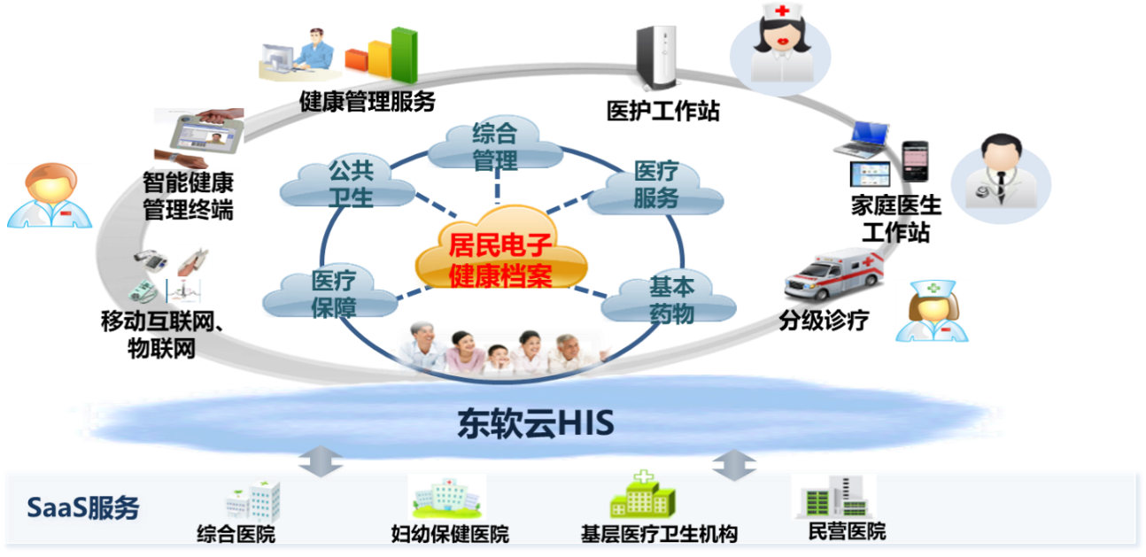

## Neusoft Cloud HIS Hospital Management System Functional Architecture

The following is the overall business function architecture of Neusoft Cloud HIS. Only some modules will be worked on during the practical training phase.

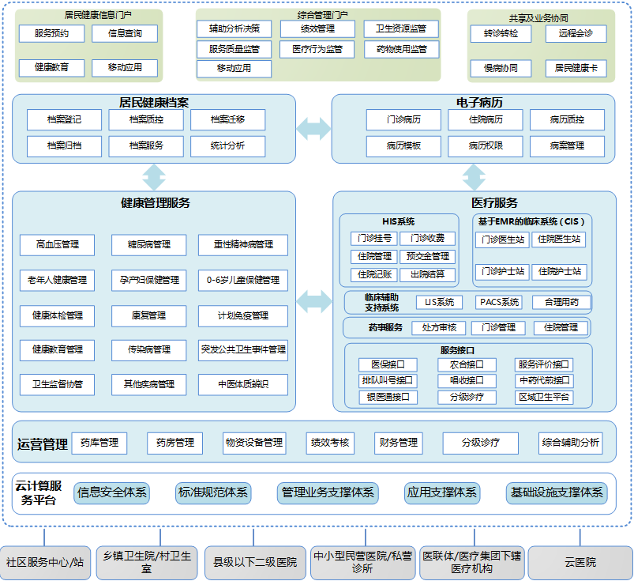

# Business process diagram

Consultation process :

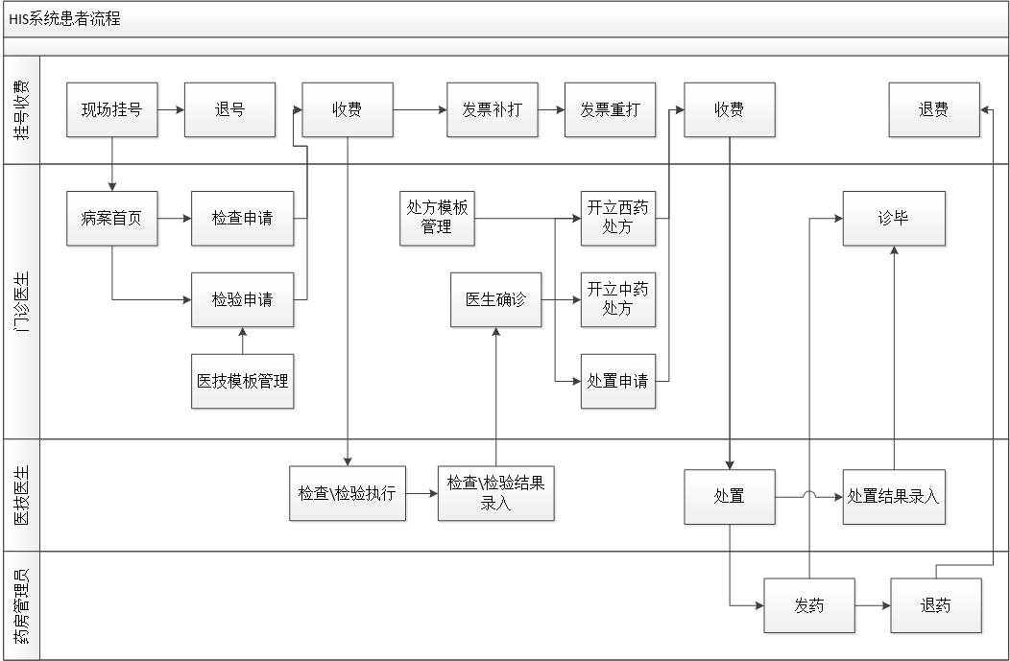

# Basic information maintenance

## Constant category management

[Application scenario]: Constant items used by system administrators to maintain the system .

The main information of constant items includes: constant item code, constant item name, constant item category, etc.

【Operation description】: query , add , modify , delete , etc.

## Department Management

[Application scenario]: Used by hospital administrators to maintain all departments of the hospital .

The main information of the department includes: department code, department name, department classification, department category, etc. For details, please refer to the "Hospital Department Category Comparison Table".

Department classification : classified according to the type of disease the doctor is responsible for diagnosing and treating, such as Traditional Chinese Medicine , Internal Medicine, Surgery, Orthopedics, etc.

Department category : According to department functions, it is divided into clinical departments, medical technology departments, financial departments, administrative departments, etc.

【Operation description】: query , add , modify , delete , etc.

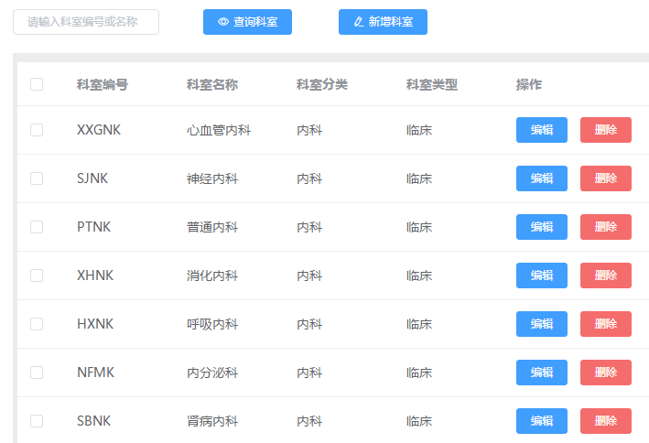

## User Management

[Application scenario]: For all users who use the system and are maintained by hospital administrators .

The basic user information includes : login name , password , real name , department of the user, user category (registration and payment collector, outpatient doctor, medical technician, pharmacy operator, financial manager, hospital manager). If the user is a doctor, the doctor's title information (chief physician, deputy chief physician, attending physician, resident physician) and whether the user is involved in scheduling are also required.

【Operation description】: query , add , modify , delete , etc.

## Registration level management

[Application scenario]: It is used by hospital administrators to maintain the registration levels used by the hospital and the corresponding registration fees for each registration level, such as general registration, expert registration, emergency registration, etc.

Registration level information includes: number code, number name, registration limit, display sequence number, and registration fee.

[Operation description]: Settlement category management such as adding , modifying , deleting , and querying

[Application scenario]: Used by hospital administrators to maintain the settlement categories used by the hospital, including self-payment, medical insurance, and new rural cooperative medical care, etc.

【Operation description】: add , modify , delete , query , etc.

## Diagnostic Catalog Management

[Application scenario]: It is used by hospital administrators to maintain the diagnosis catalog information used by doctors when prescribing diagnoses, including classification names and classification codes. At the same time, under the classification, maintain disease information. For specific diseases, please refer to the International Classification of Diseases (ICD-10) catalog, including disease codes (pinyin mnemonics), disease names, international ICD codes, and disease classifications.

[Operation description]: Add, modify, delete, query, maintain diagnostic classification, etc.

## Non-drug charge item management

[Application scenario]: Used by hospital administrators to maintain non-drug charging items used in the hospital. For details, please refer to the "Non-drug Catalog".

【Operation description】: query , add , modify , delete , import, export, etc.

## Doctor scheduling management

[Application scenario]: It is used by hospital administrators to maintain the hospital's doctor outpatient scheduling information. Only clinical departments are involved in scheduling, and medical technology departments are not involved in scheduling.

[Operation description]: Set scheduling rules and generate scheduling plans.

1. Set up scheduling rules : Maintain scheduling rules for doctors who need to be scheduled according to Monday to Sunday and noon (morning/afternoon).

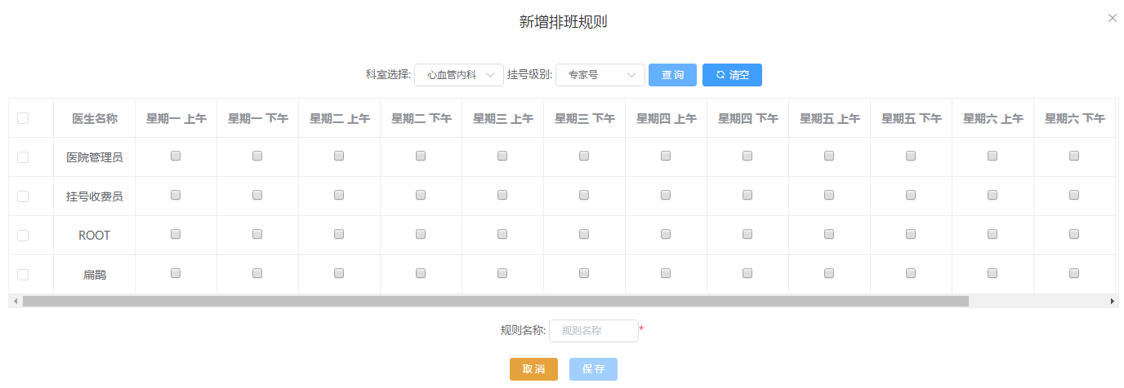

1. Generate a shift schedule: Enter the start date and end date, click the "Select rules to generate a shift schedule" button, and generate a doctor's shift schedule for the specified start and end time period according to the set shift schedule rules. You can also modify the generated shift information, but you cannot modify the historical shift information. The newly generated shift information will overwrite the shift information of the same time.

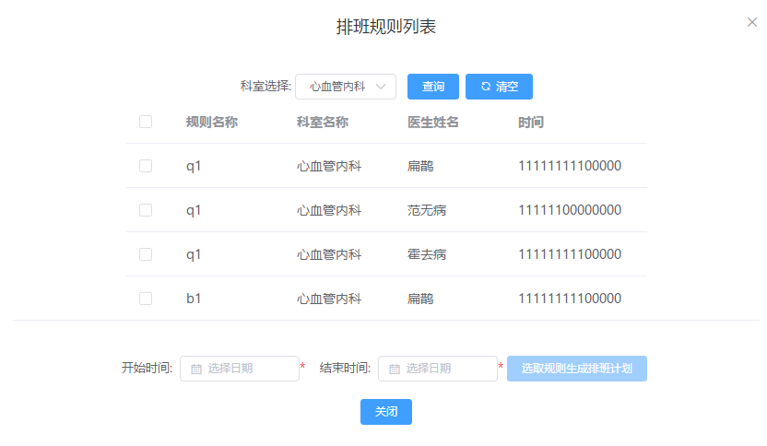

# Outpatient registration fee

## On-site registration

[Application scenario] : When a patient goes to the hospital for medical treatment, he/she must first register for outpatient services. At the registration desk, he/she must register the patient's basic information, registration level, registration department, and doctor. After the patient pays, the registration invoice is printed. After the registration is completed, the patient can go to the doctor's station to receive medical services . Otherwise, the patient will not be seen at the doctor's station .

For doctors with limited appointments , no further appointments can be made once the number of appointments is reached.

The information entered when registering includes : medical record number (automatically generated, unique, required), name (required), gender ( required ), age , date of birth (enter one of age and date of birth, the other will be automatically calculated), settlement category (required), ID number , home address , registration level (required), registration department (required), doctor (required), whether to have a medical record book (if a separate fee of 1 yuan is required), amount receivable (automatically calculated by the system based on the registration level and doctor, and whether a medical record book is required)

[Operation description]: Register, clear, update invoice number

1. Registration : After the registration cashier enters the patient information , the registration operation is carried out and the patient status is "registered". It can be queried by the registration doctor.
2. Clear : If you want to re-enter the patient registration information , you can clear the entered content .
3. Update the current invoice number: When the invoice number in the system is inconsistent with the actual invoice number , you need to modify the current invoice number in the system to avoid inconsistency between the actual invoice number used and the invoice number recorded in the system .

## Cancel account

[Application scenario]: When a patient makes a wrong appointment or does not see a doctor, he or she can cancel the appointment by canceling the appointment. After the patient's fee is refunded, the patient's invoice is collected and an invoice receipt is printed (also called a red invoice, with a negative amount). The billing staff will staple the two invoices together and the amounts will offset each other.

【Operation description】：Exit

1. Refund: Enter the medical record number on the invoice to query the patient's registration information. Only the registration records in the "No Consultation" status can be refunded. Click the " Refund " button to display the patient's registration fee that should be refunded. After the corresponding amount is refunded, print the red refund receipt.

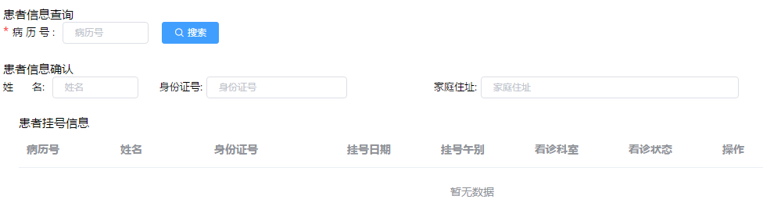

## TOLL

[Application scenario]: When a patient visits a doctor's station for consultation, the doctor will prescribe corresponding examinations, tests, or medicines based on the patient's condition. This function is mainly used to charge for these items and print invoices at the same time.

【Operation description】 ：Charge

1. Charge : Enter the patient's medical record number, and the patient's registration information, items that have not been charged for the patient, and the total amount of pre-charged items will be automatically displayed. Click the " Charge " button, enter the payment method and the actual amount collected, and the system will automatically calculate the change amount. Click the "Confirm" button, the charge is completed, and the invoice is printed.

After the payment is completed, the doctor's station, pharmacy, and medical technology station will see that the item has been paid and can proceed with the distribution of medicines, registration of medical technology examinations/tests, etc.

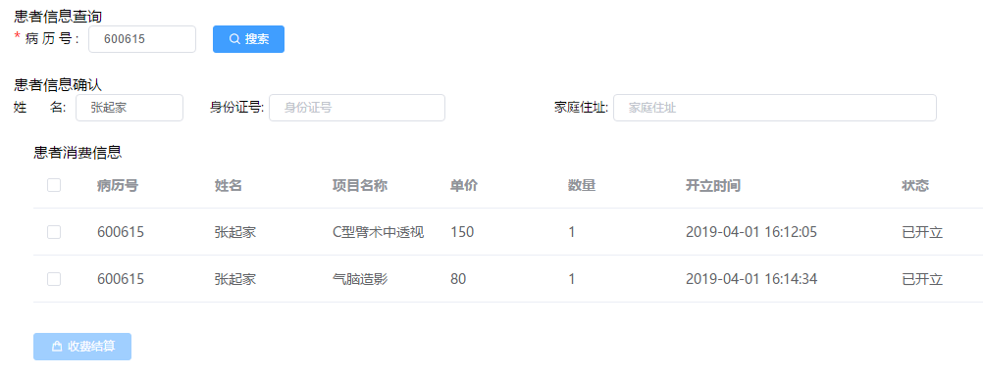

## Refund

[Application scenario]: It is used in scenarios where patients need to refund after paying but have not made corresponding purchases. When refunding, the corresponding invoice of the patient should be collected and a red invoice should be printed at the same time.

【Operation description】 ：Refund

1. Refund: Through the patient's medical record number, the patient information, all opened items and current status are automatically displayed. Only items that are not consumed can be refunded. Unconsumed items can be refunded in full or in part. After the input is completed, the corresponding amount will be refunded to the patient, and the invoices for the remaining items will be reprinted, and the invoices in the patient's hands will be collected.

Note : For items to be refunded , if they are medicines and the patient has already received the medicines, they must first go to the pharmacy to return the medicines. If they are non-drugs (examinations, tests, treatments, medical materials, etc.), they must be in an unregistered status before a refund can be made .

## Reprint invoice

[Application scenario]: Reprinting invoices: Sometimes, the invoice printing fails because the printer is out of paper or the printer does not feed paper for other reasons. In this case, you need to reprint the invoice for the patient. Note: Before reprinting the invoice, you need to update the current invoice number to avoid inconsistency between the invoice number recorded in the system and the actual invoice number used.

## Reprint invoice

[Application scenario]: Invoice reprinting: Sometimes, although the invoice is printed successfully, the information on the invoice may be wrong or unclear. In this case, the invoice needs to be reprinted. When the invoice is reprinted, the original invoice must be collected and invalidated.

## Patient cost inquiry

[Application scenario]: Used to query patients' expense information.

【Operation description】 ：Query

1. Query : Enter the patient's medical record number (required), start time and end time (optional). Query the list of all charges for the patient, sorted in descending order by charge time by default.

## Toll collector daily settlement

[Application scenario]: It is used for registered toll collectors to settle accounts every day and report to the finance department. At the same time, they can query their historical daily settlement data.

[Operation description] : Daily settlement, daily settlement history query.

1. Daily settlement : The toll collector enters the statistical time (the starting time is the closing time of the previous daily settlement). Only the closing time needs to be entered. The default is the current time. The time later than the current time cannot be entered. Click the " Daily Settlement Statistics " button to count the collection amount and the corresponding invoice information between the closing time of the previous daily settlement and the current daily settlement. Click the "Settlement Report " button to freeze the collection records in the statistical time period.

After the daily settlement , the operator will go to the Finance Department to report the expenses with the daily settlement sheet , the corresponding invoice , and the corresponding amount or card receipt .

1. Daily settlement history query : specify the query start and end time. Click the " Query " button, and the system will display the daily settlement information within the specified condition range. Click on one of the daily settlement information to display its corresponding information, including the daily settlement summary and its corresponding invoice information.

# Outpatient doctor workstation

After the registration is completed, the patient can go to the doctor station to receive the consultation service. Otherwise, the doctor station will not be able to see the patient. The main functions of the outpatient doctor station include: outpatient medical record homepage, examination application, test application, outpatient confirmation, treatment management, prescription of finished medicines, prescription of herbal medicines, completion of consultation, patient expense list, medical record template management, examination template management, test template management, treatment template management, prescription template management, doctor workload statistics, etc.

The page of the outpatient doctor station is divided into two areas:

1) The left side is the patient list area (including the list of patients waiting to be diagnosed and the list of patients who have been diagnosed)

[Patient Refresh]: When the patient's registration or consultation status changes, the patient list will not be refreshed immediately in real time. You can click the refresh button to reload the patient information when necessary.

[Hide/Show Patient List Area]: The patient list area can be hidden or displayed by clicking the button.

【Patient Query】: You can query according to the patient's name, which makes it convenient for doctors to find patients quickly.

[Myself] The following table is a list of patients who have registered with the currently logged-in doctor;

[Department] The following table is a list of patients who have registered with the department where the currently logged-in doctor is located;

2) On the right is the outpatient doctor's operating area.

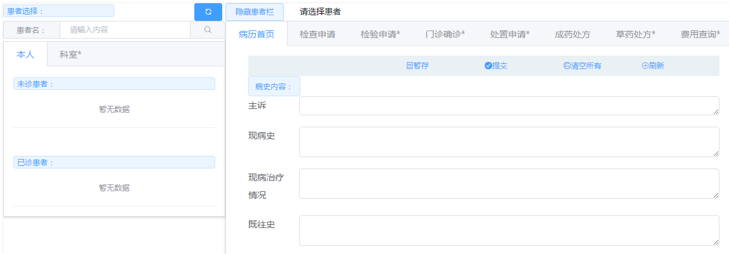

## Outpatient medical records home page

[Application scenario]: When a doctor sees a patient for the first time, he or she needs to ask the patient for some information. This information is called the "medical record homepage". The main contents include: chief complaint, current medical history, current medical treatment, past medical history, allergy history, physical examination, preliminary diagnosis (Western medicine) or preliminary diagnosis (Traditional Chinese medicine), examination recommendations, and precautions. All items must be filled in.

[Operation description]: Patient selection, temporary storage of medical record homepage, submission of medical record homepage, clear screen, save as template, reference template medical record, common diagnosis management, view historical medical records.

1. Patient selection : By clicking on the patient's name , the corresponding patient's medical record homepage information will be displayed .
2. Temporarily save the first page of medical records : The doctor fills in the contents of the first page of medical records based on the patient's inquiry . In order to prevent the system from being abnormal if not operated for a long time, the "temporary save" function can be used to temporarily save the data on the first page of medical records.
3. Submit the medical record homepage : After the doctor enters the patient's medical record homepage information, click the "Submit" button, and the system checks whether all items are filled in completely. After filling in, the system saves the patient's medical record homepage information. Only then can the doctor perform operations such as inspection, testing, treatment, and prescription.
4. Clear screen : Clear the medical record information filled in the current page.
5. Refresh: Reload the medical record homepage information of the currently selected patient.

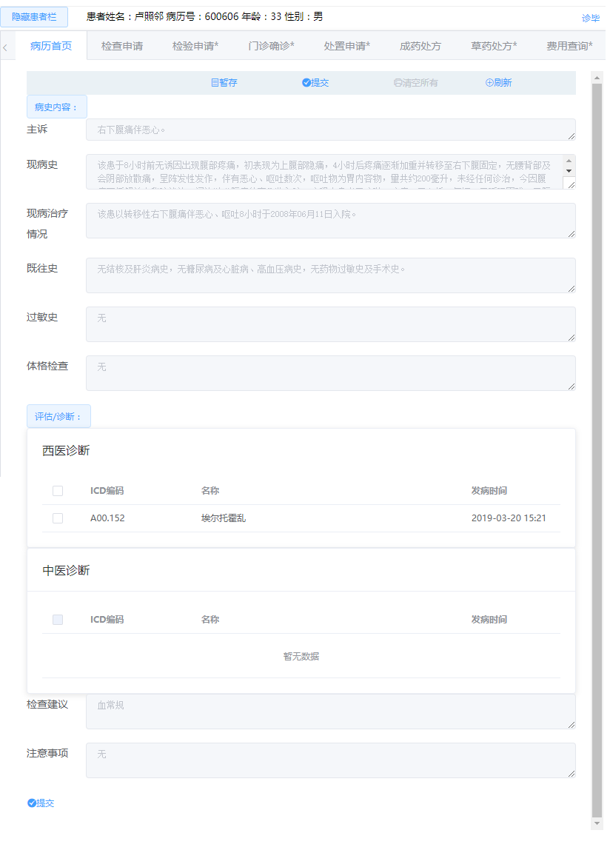

1. Preliminary diagnosis (Western medicine) or Preliminary diagnosis (Traditional Chinese medicine): If the patient's medical record homepage has not been submitted, you can select the disease information for the preliminary diagnosis. You can only choose one disease diagnosed with Western medicine or one diagnosed with Traditional Chinese Medicine, but you can select multiple diseases diagnosed with Traditional Chinese Medicine or Western Medicine.

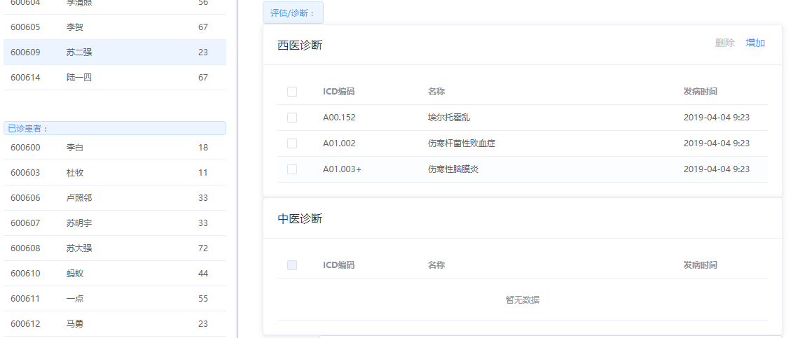

[Extended information]: Medical records (problem description, medical history records) are recorded in the form of SOAP.

S: represents the patient's subjective data (Subjective data):

Subjective information is provided by the patient or his/her companion during medical treatment, including the patient's complaints, symptoms, subjective feelings of discomfort, worries, medical history, family history, and social life history. The doctor is required to describe the above situations in the language of the patient as close as possible.

0: represents objective data:

Various real data obtained by observers (generally doctors) using various methods, including physical examination findings, physiological data, laboratory test results, psychological and behavioral measurement results, and the attitudes and behaviors of patients observed by doctors.

A: stands for Assessment of Health Issues:

Estimates are the most important part of problem description.

The content may be illness or symptoms and/or complaints of unknown cause

P: stands for the plan to solve the problem (Plan) :

Treatment plans are proposed for problems and are not limited to prescribing drugs. The plan should generally include diagnostic plans, treatment strategies (including medication and treatment methods), etc.

## Check application

[Application scenario]: After the doctor has filled in the information on the "Medical Record Home Page", if he cannot confirm the patient's condition, he needs to use the corresponding examination/test items to assist in the diagnosis. This function is mainly to provide doctors with corresponding examination applications.

[Operation description]: Add items, delete items, open items, cancel items, save as sets, reference sets, and view inspection results .

1. Add new items: Click "Add new items" and the system will display all current inspection items. Items can be searched based on item mnemonics. After selecting the corresponding item, enter the name of the item inspection, purpose requirements, inspection area, and whether it is expedited to complete the addition of the item.
2. Delete items: For inspection items that have not been opened, you can select them in the item list and click "Delete" to delete the specified item.
3. Opening items: For newly added items, the default status is temporary storage, and the medical and technical department staff and the collection staff cannot view it. You need to click "Open" before the corresponding inspection items will take effect, and the medical and technical department staff and the collection staff can perform operations.
4. Cancel project: For the opened project, you can click "Cancel" to cancel the specified project . Note : The project registered in the medical technology department cannot be canceled.
5. View examination results : For completed examinations, after the medical technician has entered the examination results, the outpatient doctor can view the examination results by clicking "View Results" on the record.

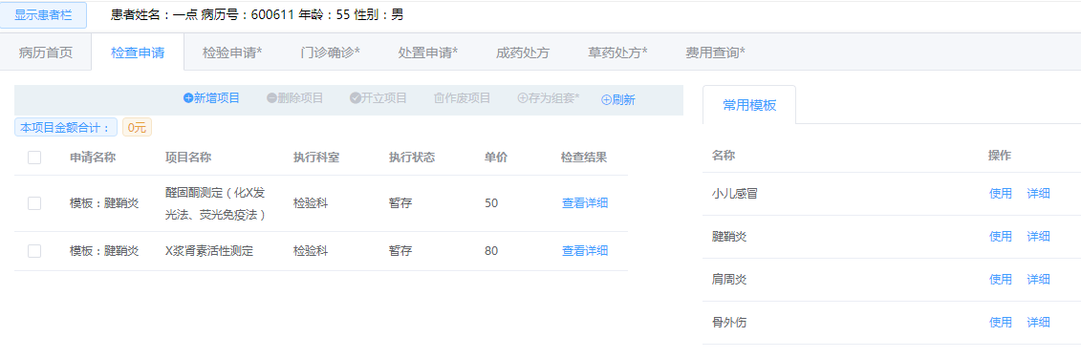

## Inspection Application

[Application scenario]: After the doctor fills in the information on the "Medical Record Home Page", if he cannot confirm the patient's condition, he needs to use the corresponding examination/test items to assist in the diagnosis. This function is mainly to provide doctors with corresponding test applications.

[Operation description]: Same as the " Inspection Application " module.

## Outpatient diagnosis

[Application scenario]: When the doctor can diagnose the patient's condition, this operation is used to confirm the patient's condition.

【Operation description】：Confirm and save

1. Confirmation and save : After locating the patient by medical record number or name , the preliminary diagnosis result in the "Outpatient Medical Record Home Page" is displayed by default on the final diagnosis information. The doctor can enter the patient's examination and test results according to the examination form\test form to confirm the patient's final diagnosis and click the "Save" button to complete the patient's diagnosis operation.

## Disposal Application

[Application scenario]: Treatment is the doctor's treatment according to the corresponding condition, such as infusion, nebulization, etc. After the doctor applies for the corresponding treatment project, the patient also has to pay, and then the corresponding execution department may see the corresponding treatment project.

[Operation description]: Same as the " Inspection Application " module.

## Prescription medicine

[Application scenario]: A prescription is a medical document issued by a registered practicing physician to a patient during diagnosis and treatment, reviewed, dispensed, and checked by a pharmacist, and used as a patient's medication voucher. A prescription is a written document of a doctor's medication for a patient, and is the basis for pharmacists to dispense medications, with legal, technical, and economic responsibilities.

When prescribing, doctors must use standard Chinese or English names and write the drug name, dosage, specifications, usage, and amount. The drug dosage and quantity must be written in Arabic numerals.

A "prescription" can only be issued after the doctor has filled out the "Medical Record Cover Page" or has confirmed it from the outpatient clinic.

Only prescriptions for over-the-counter medicines can be filled in here .

[Operation description]: Write a prescription, delete a prescription, send a prescription, cancel a prescription, add medicine, delete medicine, and quote a set.

1. Prescription: Click "Add Prescription" and the doctor will be asked to enter the prescription name and select OK. If you do not enter the prescription name, the default name is "Add Prescription + Number". The status of the prescription at this time is temporary. Prescriptions in this state can be modified or deleted.
2. Delete prescription: Only prescriptions in temporary state can be deleted. Click "Delete Prescription" to delete the prescription.
3. Send prescription: After the doctor confirms that the prescription is correct, click "Send". After the prescription is sent, the cashier can start charging.
4. Void prescription : A prescription cannot be deleted after it is issued. You can click "Void" to void the prescription. Void prescription means that the payment person page cannot see the prescription information and cannot mark the price for payment.
5. Add medicine : Select a prescription in temporary state, click "Add medicine", and then select the medicine (you can query the medicine information according to the medicine code, pinyin code, etc.). The doctor needs to fill in the medicine usage, medicine dosage, frequency of use, and quantity, etc. After filling in the medicine information, you can click "Add" to complete the operation of adding medicine. You can choose the medicine to add to the prescription here; according to national regulations, each prescription can contain a maximum of 5 medicines. If it exceeds, you need to add a new prescription.
6. Delete medicine : Select the prescription in temporary state , select the medicine to be deleted , and click "Delete medicine" to delete the medicine. You cannot add or delete medicine in the prescription that has been issued.
7. Reference set : When creating a new prescription, you can select a set from the prescription template. The detailed items will be listed in the template details. Click " Use this template" to add a prescription and include the drugs in the template.

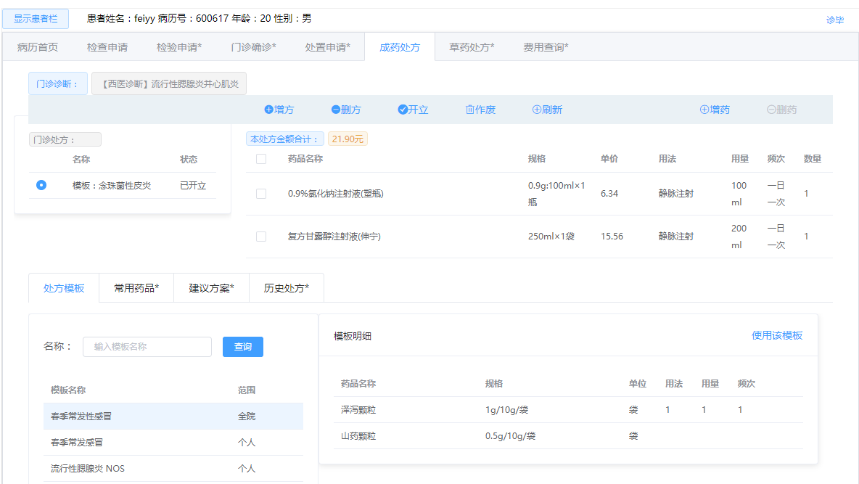

## Herbal prescription

to perform the corresponding operation of herbal medicine prescription after the doctor fills in the first page of the medical record or confirms the diagnosis of traditional Chinese medicine in the outpatient clinic.

[Operation description]: The operation is the same as “prescription for finished medicine”.

## After the consultation

[Application scenario]: When the patient finishes the consultation, the doctor uses this function to end the consultation. After the consultation, no more examinations or tests can be applied for the patient, and no medicines can be prescribed or charged.

【Operation description】：Diagnosis completed

End of consultation : Select the corresponding patient by medical record number or name , click "End of consultation" to end the consultation.

## Patient expense details inquiry

[Application scenario]: Used to query the patient's consultation fee details , which can be queried based on the patient's name or medical record number.

[Operation Description]: To query, you can enter the patient's medical record number or name, as well as the project category. The query results are sorted in ascending time order by default.

## Medical technology template management

[Application scenario]: Medical technology packages are mainly used by doctors to save typical and common examinations as packages when applying for examinations , tests , and treatments according to their needs . They can be referenced in subsequent examination application processes to improve the efficiency of examination , test , and treatment applications .

[Operation description]: Add template, modify template, delete template, query template, add project.

Template information mainly includes : template name , template application scope (all staff, department, individual), template type (inspection, testing, disposal), creating doctor, creation time, and whether the template contains project management.

1. new template: Enter the template name, applicable scope of the set (individual, department, whole hospital), template type (inspection, testing, disposal), and click "Save" to save the template.
2. Modify template: modify the template information.
3. Delete template: delete the template .
4. Query template: You can query based on template name , template range, and template type .
5. Add items to the template : Click "Add Item", select the item to be added in the item list (you can use the mnemonic code to search for the item), enter the part to be inspected and click "Add" to complete the addition operation.
6. Delete items in the template : After selecting a template , a list of items in the template will be displayed. Click the item you want to delete to complete the deletion operation.

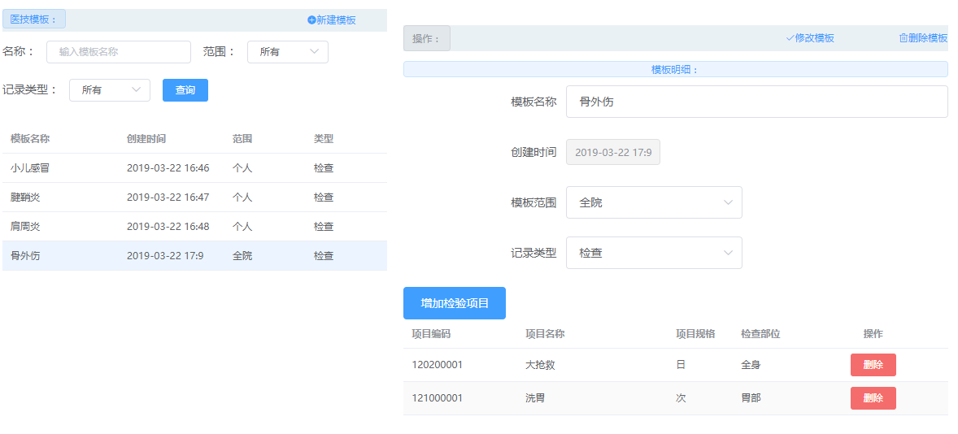

## Western medicine prescription template management

[Application scenario]: Prescription sets are mainly used by doctors to save typical and common prescriptions as sets according to their needs , and can be referenced in the future prescribing process to improve the efficiency of prescribing .

[Operation description]: Same as “Medical technology template management”.

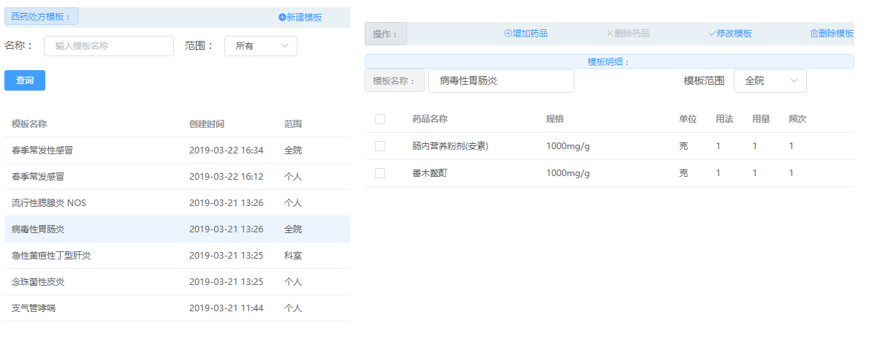

## Chinese medicine prescription template management

[Application scenario]: Prescription sets are mainly used by doctors to save typical and common prescriptions as sets according to their needs , and can be referenced in the future prescribing process to improve the efficiency of prescribing .

[Operation description]: Same as “Medical technology template management”.

# Outpatient medical technology workstation

After the outpatient doctor has applied for the corresponding examination / test items and the patient has paid the fee at the registration and cashier office, the doctor in the corresponding medical and technical department can see the examination / test application items that the department should perform.

The main functions of the outpatient medical technology station include: patient examination, patient testing, patient treatment, medical technology management, etc.

## Patient examination

[Application scenario]: This function is mainly used after the outpatient doctor has given the patient an examination application, and the patient has paid the fee and then goes to the medical technology station for the examination.

[Operation description]: Patient query, execution confirmation, execution cancellation, and filling in results.

1. Patient query: Enter the patient's medical record number or name to query the patients waiting for treatment in this department. Select the patient to see the patient information and the details of the applied project.
2. Execute Confirmation: Select the corresponding patient and click the "Execute Confirmation" button to proceed with the registration. Note: Only items that have been paid can be registered.
3. Cancel execution: Select the corresponding patient and click the "Cancel Execution" button to cancel the operation. Note: Generally, the cancellation operation will not be performed.
4. Result entry: After selecting the corresponding patient and item, click the "Result Entry" button to enter the examination results. If the examination item has pictures, upload the examination result pictures.

## Patient Testing

[Application scenario]: This function is mainly used when the outpatient doctor applies for an examination for the patient, and the patient pays the fee and then goes to the medical technology station for the examination.

[Operation description]: Same as “Patient examination”.

## Patient Disposition

[Application scenario]: This function is mainly used after the outpatient doctor has given the patient a treatment application, and the patient has paid the fee and then goes to the medical technology station for the treatment project.

[Operation description]: Same as “Patient examination”.

## Medical Technology Management

[Application scenario]: Used by hospital administrators to maintain medical and technical charging items used in the hospital.

【Operation description】: query , add , modify , delete , import , export, etc.

# Outpatient Pharmacy Workstation

After the outpatient doctor writes the corresponding prescription and the patient pays the fee at the registration and payment office, the pharmacy administrator can see the corresponding prescription information.

outpatient pharmacy workstation include: dispensing, returning, and managing drug catalogs.

## Outpatient medication

[Application scenario]: The patient takes the payment invoice to the pharmacy window. The pharmacy administrator queries the corresponding paid but undistributed drug information based on the patient's medical record number and then dispenses the drug to the patient.

[Operation description]: Query and dispense medicine.

1. Query: Enter the query conditions, medical record number , time , and click the "Query" button to query the corresponding patient's drug information.
2. Dispense medicine : Select the medicine that the patient has paid for but not yet dispensed, and click Dispense to dispense the medicine. Note: The pharmacy will only receive the dispensing information after the payment is completed, otherwise it will not be visible.

## Outpatient drug withdrawal

[Application scenario]: This operation is used when the patient wants to return the medicine that he has received but has not used it. If you want to get a refund, you need to return the medicine first.

【Operation description】：Query, return medicine

1. Query: Enter the query conditions, medical record number , time , and click the "Query" button to query the corresponding patient's drug information.
2. Return medicine : Select the unused medicine that the patient has returned and click Return medicine to return the medicine. Note: You can only go to the refund window to perform the refund operation after the return of medicine is completed, otherwise you will not see it.

## Drug management

[Application scenario]: Used by pharmacy administrators to maintain drug information used in the hospital.

Drug information includes: drug code (unique), drug name, pinyin mnemonic code, drug specifications, dosage form (injection, tablet, capsule, etc.), packaging unit, unit price, drug type (Western medicine, Chinese patent medicine, Chinese herbal medicine), etc. For details, please refer to the "Drug Catalog" file.

【Operation description】: query , add , modify , delete , import, etc.

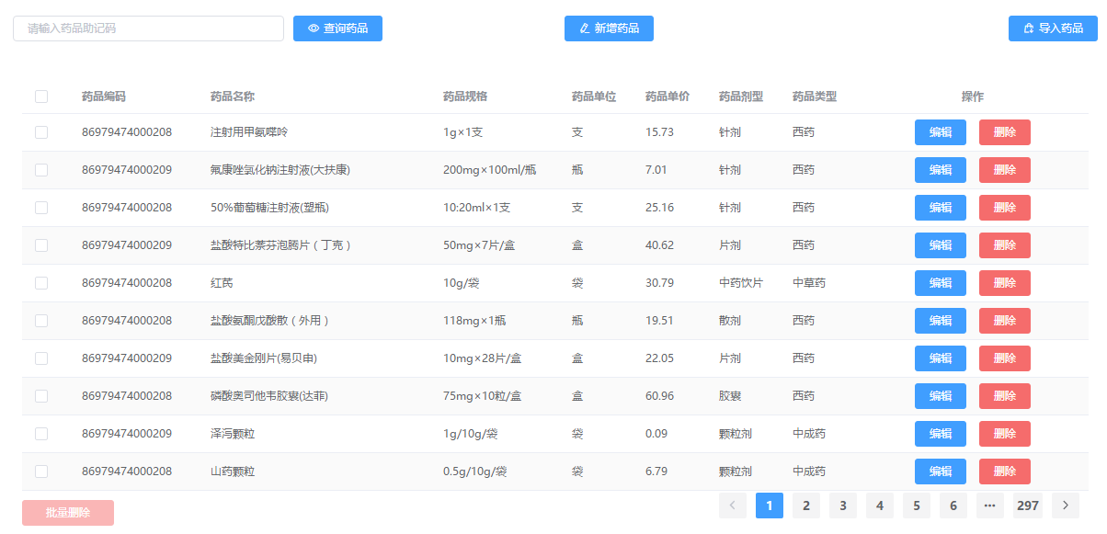

# Outpatient Financial Management

## Expense Account Management

[Application scenario]: It is used by financial administrators to maintain the expense items in the system, that is, the major categories of charges printed on invoices, such as Western medicine fees, Chinese patent medicine fees, Chinese herbal medicine fees, registration fees, medical treatment fees, etc. For details, please refer to the "Expense Items" file.

【Operation description】: add , modify , delete , query , etc.

## Outpatient day tuberculosis

[Application scenario]: When the toll collector reports the bill every day, this function can be used to query the amount that the toll collector should report and the number of invoices reported.

[Operation description]: Daily verification.

Daily verification: designate a toll collector, click query, and the system will automatically find out the amount and invoice information that the toll collector should pay but has not yet submitted. When the above query results are consistent with the materials actually submitted by the toll collector , click the " Verify Pass " button to complete the financial warehousing operation .

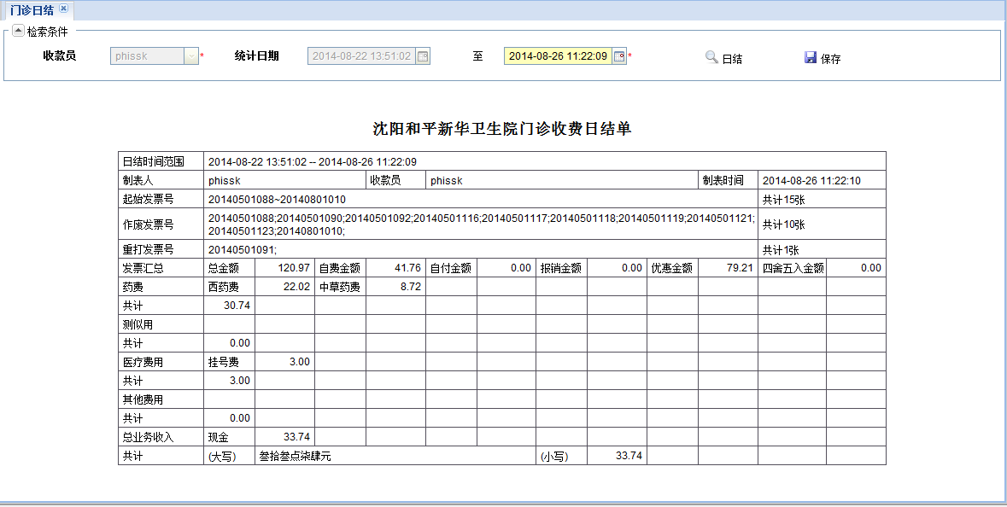

## Workload statistics of outpatient departments

[Application scenario]: It is used by financial staff to count the total income and sub-item income of each department during a specified period of time. Statistics can be calculated by the billing department or by executing department, as shown in the figure.

【Operation description】 : Workload statistics of clinical departments and medical technology departments

Enter the statistical start and end time, click the query button, and query the total income of each department and the income of each item. Export the query results by clicking the export button.

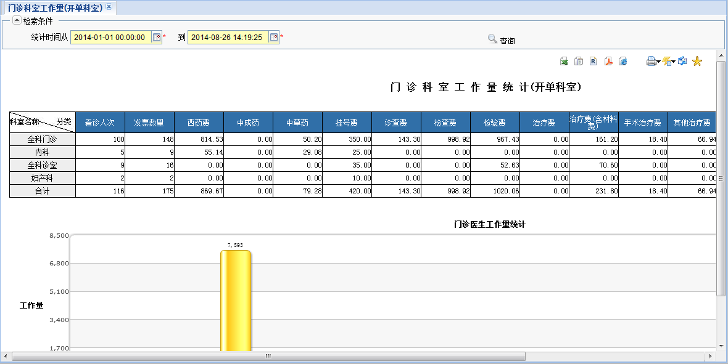

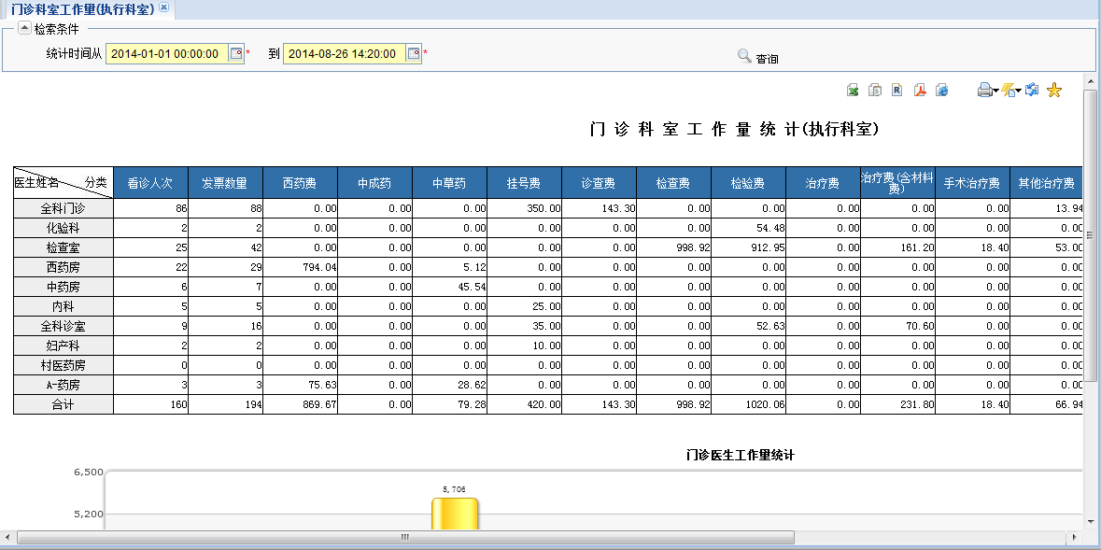

## Statistics on workload of outpatient doctors

[Application scenario]: It is used by financial staff to count the workload of doctors in a specified time period, as shown in the figure.

[Operation Description]: The operator enters the statistical start and end time, clicks the query button, and queries the number of visits, number of invoices, each sub-item income and total income. By clicking the export button, the statistical results can be exported.

